Data Quality Report

- Introduction
This project intends to assess information on residential properties purchased in Ireland since 2010. We use data collected by the Residential Property Price Register (RPPR) and look into a subset of the data. This Data Quality Report will go through each feature of the sub-dataset and provide a summary of key issues within the data and potential strategies to deal with them.

- Findings and Strategies
In this part of the report, we will analyze each feature, check their integrity, and summarize with main problems of each feature and potential solution to them. Table 1 shows an overview of our assessment of each feature, which will be elaborated in this part.

  - DateofSale(dd/mm/yyyy)
Initial input of DateofSale(dd/mm/yyyy) is viewed as an object variable because all of the input are strings of dates. From our dataset, residential property transactions span from 2016 to 2024. That brings to the key issue of DateofSale(dd/mm/yyyy): raw record of this feature is too precise to provide valuable insights of our research so far. Cardinality of this feature is 2482, which is relatively high. That means we have random sales dates between 2016 to 2024, making it hard to converge upon specific trends on each single day and reducing data interpretability. Keeping the feature this way may negatively affect later analysis, specifically making it discrete or less trustworthy. To address this issue, we propose to extract month and year out of the original input. Aggregating transactions to a monthly level is more appropriate for analyzing property market trends and compare across periods.

  - Address
Feature Address is treated as an object variable because all of the input are strings of address. Similarly to DateofSale(dd/mm/yyyy), Address also reports a high cardinality of 53357, nearly 99% of the dataset. That means, if we solely assess the dataset on Address, we will analyze single and separate properties. So, a similar problem is found here: Address is so scattered that it cannot provide aggregated trends. Since location is an important deciding factor regarding residential properties, instead of dropping the feature, we need to aggregate Address to identify reginal trends. To solve this issue under Irish context, it can be helpful to convert original input into Eircode. Starting from Eircode, we can identify reginal housing market trends.

  - County
Feature County is treated as a categorical variable because inputs are finite values, i.e. Irish counties in our context. County reports no significant issues shown here. There are no missing entries. Cardinality is 26, matching with administrative division of Ireland. As location-related features are important when considering housing market, we propose to keep this feature for further investigation. To have a deeper analysis, Figure 1 plots out this feature. It is clear that most transactions are concentrated in Dublin, while Cork and Kildare respectively, have the second and third highest number of house transactions. This figure also shows the necessity to look into Dublin and compare trends across different districts within Dublin.
  - Eircode
Feature Eircode is viewed as an object variable as inputs are strings of postcode. There are two issues that are worth discussing. Firstly, the missing rate of this entry is reported as 68.86%, probably RPPR treated it as an optional input. This may negatively impact later research because Eircode is a common way to extract regional information, but only assessing the 30% valid input does not lead to a robust conclusion. In this way, we propose to combine with the Address feature, try to fill more missing Eircode from exact addresses.

Secondly, cardinality of Eircode feature records as 16,761, which is relatively high. That means we will assess 16,761 different buildings, making it harder to identify aggregated trends. To address this, it is helpful to extract district information from Eircode, and to see if this can lead to regional trends for a certain area.

  - Price
Feature Price is considered as a continuous feature as it refers to the actual volume of house transactions. From Figure 2, it is reported that house prices range from €5,250 to €221,942,731, with a mean of € 330,160.11. From the histogram of Figure 2, xxxxx. From the Boxplot of Figure 2, xxxxx.

Meanwhile, we identified outliers and extreme values for Price feature. The maximum value, €221,942,731, seems to be an outlier. Xxxx

  - NotFullMarketPrice
Feature NotFullMarketPrice is viewed as a categorical variable because it has binary values. To be clearer, there is a variety of reasons for a property to be sold not at full market price, such as this transaction only includes a fraction of this property, this transaction is at a reduced price under the Affordable Homes Scheme etc. However, this is not the major scenario of our dataset. Figure 3 shows that nearly 95% of house transactions are at full market price. This helps rule out some edge cases. There are no significant issues identified regarding NotFullMarketPrice feature. Since Price is the target feature, we can keep other price-related features to provide more information to later research. Thus, we keep NotFullMarketPrice feature.

  - VATExclusive
Feature VATExclusive is treated as a categorical variable because it has binary values. From RPPR, the definition of this feature is that for new properties, their prices are exclusive of a 13.5% VAT. From our dataset, as shown by Figure 4, prices of around 18% of properties do not include the VAT. There are no key issues reported on VATExclusive feature. When we assess the target feature, Price, it will be thorough for us to consider potential VAT for new properties. Therefore, we propose to keep VATExclusive feature for helping reach a robust conclusion.

  - DescriptionofProperty
Feature DescriptionofProperty is viewed as a categorical variable because the input has finite values. This feature categorized residential properties into three types: New Dwelling house/Apartment, Second-Hand Dwelling house/Apartment, and Teach/Árasán Cónaithe Atháimhe. From Figure 5, around 82% of house transaction is on Second-Hand Dwelling house/Apartment. When we further investigate the Price feature, we can provide elaboration on price performance of different types of houses with DescriptionofProperty feature. There are no key issues worth attention. In this way, we propose to keep DescriptionofProperty feature.

  - PropertySizeDescription
Feature PropertySizeDescription is considered as categorical variable because it has finite values of input. This feature categorizes property size. However, the missing rate of nearly 95% is worth discussing. It is clear that we cannot rely on the 5% valid input to drive a robust conclusion. Also, there is no public disclosure of property size for each house transaction. So, it is not easy for us to fill in this feature. Therefore, we propose to drop this feature due to the lack of valid input.

  - Others
As Table 2 shows, we identified four duplicate rows of input. For each pair of duplicate rows, they have the same input for every feature. In this way, duplicates may be caused by recording error. We propose to remove all these duplicate rows to prevent double-counting for identical transactions and to ensure the accuracy and integrity of later research.

- Conclusion
xxxx

Appendix

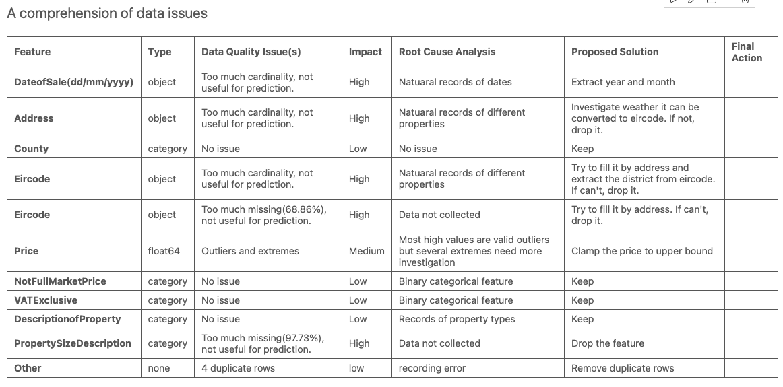
Table 1. An overview of data issues

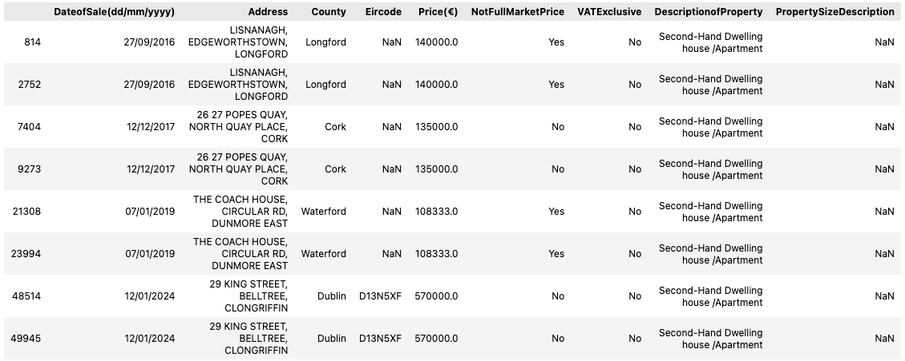
Table 2. Duplicate data
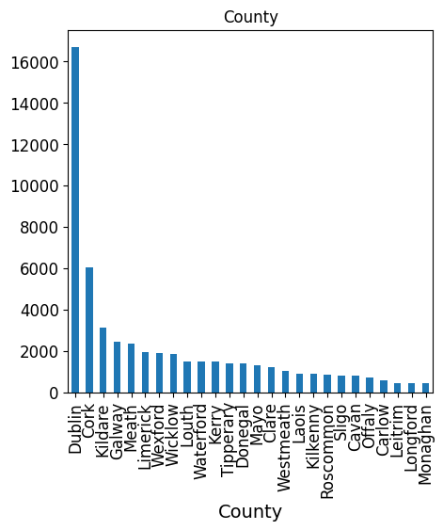
Figure 1. Bar chart on County

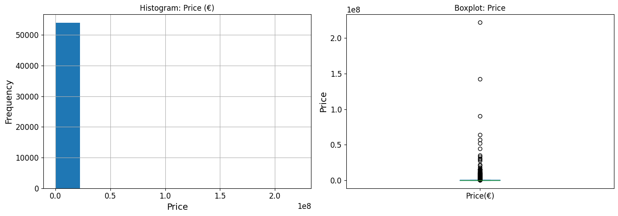
Figure 2. Plot on Price

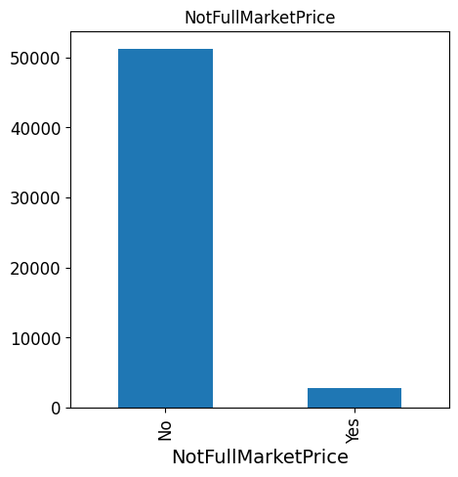
Figure 3. Plot on NotFullMarketPrice

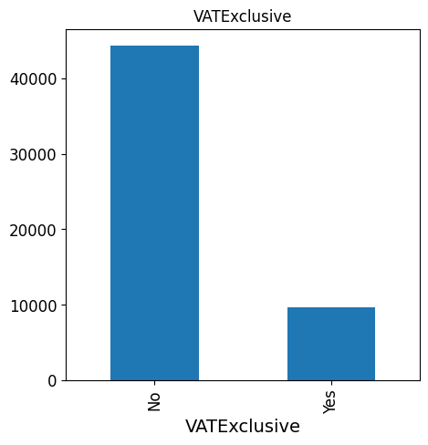
Figure 4. Plot on VATExclusive

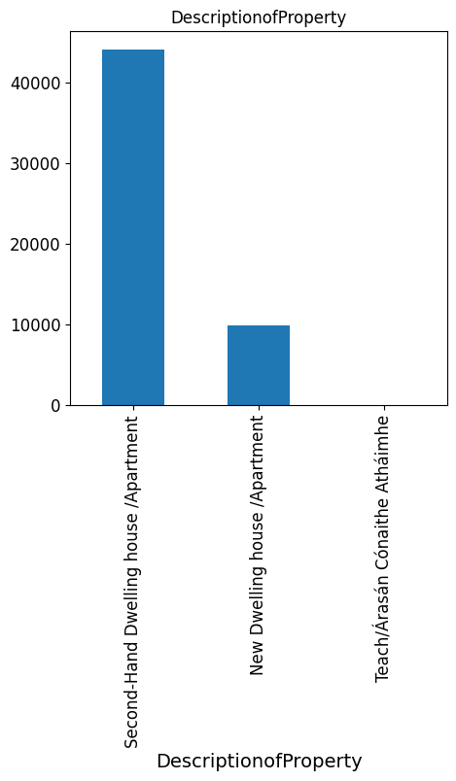
Figure 5. Plot on DescriptionofProperty

